

**COMSATS UNIVERSITY ISLAMABAD**

**(ATTOCK CAMPUS)**

PROJECT REPORT

Sahar Malik |FA18-BCE-011|

Ayesha Nasir |FA18-BCE-006|

Aqeel Abbas |FA18-BCE-005|

Semester Project |Digital Signal Processing|

Speech Processing Using MATLAB

Submitted To: Sir. Mubashir Rehman

**Speech Processing Using MATLAB**

**Objectives:**

* To use the function of MATLAB for recording of speech about 5 seconds at sampling frequency of 32 kHz
* To read the signal and then to plot the time and frequency domain magnitude spectrums of speech signal using MATLAB functions.
* To decimate the signal by factor of 2 at least 4 times and then play the sound.
* To observe the changes by decimating the speech signal

**Introduction:**

The project is about audio speech processing. Speech process refers to the analysis of speech signals and their processing to obtain useful information. Speech processing can also be referred as digital signal processing, as the speech signals are digitized for processing.

**Functions Used in Project:**

* **For recording an audio file on MATLAB:**

wavrecord();

* **For playing an audio file:**

wavplay();

* **To find highest frequency:**

fft();

* **To write an audio file:**

audiowrite();

* **To read an audio file:**

wavread();

* **To plot frequency domain spectrum:**

freqz();

* **To plot time domain spectrum:**

plot();

* **To decimate the signal:**

decimate();

**Working of Project:**

In this project we first recorded our speech on MATLAB using MATLAB command of 5 seconds at sampling frequency 32kHz. Then we audiowrite the recorded speech signal which means the speech we recorded has saved in the memory location of that file and, saved the file with type “.mat”.

Then we read that “.mat” file from new script file and call it as “filename.wav”, plotted its frequency domain magnitude spectrum and time domain spectrum. Then we found the highest frequency of the recorded speech signal using the command of Fourier Transform(fft) and plotted it.

Then we decimated the speech signal by factor 2 and plotted its frequency domain magnitude spectrum and time domain spectrum. Again, decimated the speech signal by factor 4, 8 and 16 and plotted their frequency domain magnitude spectrum and time domain spectrum and observed the results.

**Code:**

**.mat File:**

clc

% sampling frequency

F = 32000;

% recording speech on MATLAB

% 5*F is recording speech of 5 secs of sampling frequency

% datatype to store the sound

y = wavrecord(5*F, F, 'int16');

% playing recorded speech

wavplay(y, F);

% it will write the speech signal of the current file(save in memory)

audiowrite('project.wav',y, F)

**Script File:**

clc

% (part a)

% wavread will read the .wav file in which speech is recorded

% y is samples or the input signal

% fs is the sampling frequency

[y,fs] = wavread('project.wav');

wavplay(y,fs);

subplot(2,1,1)

% plotting frequency spectrum

% y is input signal

freqz(abs(y))

% setting axis limits

x = linspace(0,0.1);

xlim([0 0.1])

ylim([-80 80])

title('Freq doamin magnitude spectrum of speech.');

subplot(2,1,2)

% plotting time spectrum

plot(y),grid on;

title('Time domain');

xlabel('Seconds');

ylabel('Apmlitude');

% figure used to make the graphs appear in different windows

figure;

% fft is Fourier Transform to find highest frequency of signal

z=fft(y);

plot(abs(z)),grid on;

title('Highest frequency');

xlabel('Freq Hz');

ylabel('Power');

figure;

% (part b)

subplot(2,1,1)

% decimating or downsampling the speech by facor 2

y1 = decimate(y,2)

freqz(abs(y1))

x = linspace(0,0.1);

xlim([0 0.1])

ylim([-80 80])

title('Freq doamin magnitude spectrum after decimating by 2');

subplot(2,1,2)

plot(y1),grid on;

title('Time domain');

xlabel('Seconds');

ylabel('Apmlitude');

wavplay(y1,fs);

figure;

% (part c)

subplot(2,1,1)

% decimating by 4

y2 = decimate(y,2*2)

freqz(abs(y2))

x = linspace(0,0.1);

xlim([0 0.1])

ylim([-80 80])

title('Freq doamin magnitude spectrum after decimating by 4');

subplot(2,1,2)

plot(y2),grid on;

title('Time domain');

xlabel('Seconds');

ylabel('Apmlitude');

wavplay(y2,fs);

figure;

% (part d)

subplot(2,1,1)

% decimating by 8

y3 = decimate(y,2*2*2)

freqz(abs(y3))

x = linspace(0,0.1);

xlim([0 0.1])

ylim([-60 60])

title('Freq doamin magnitude spectrum after decimating by 8');

subplot(2,1,2)

plot(y3),grid on;

title('Time domain');

xlabel('Seconds');

ylabel('Apmlitude');

wavplay(y3,fs);

figure;

% (part e)

subplot(2,1,1)

% % decimating by 16

y4 = decimate(y,2*2*2*2)

freqz(abs(y4))

x = linspace(0,0.1);

xlim([0 0.1])

ylim([-50 50])

title('Freq doamin magnitude spectrum after decimating by 16');

subplot(2,1,2)

plot(y4),grid on;

title('Time domain');

xlabel('Seconds');

ylabel('Apmlitude');

wavplay(y4,fs);

**Outputs:**

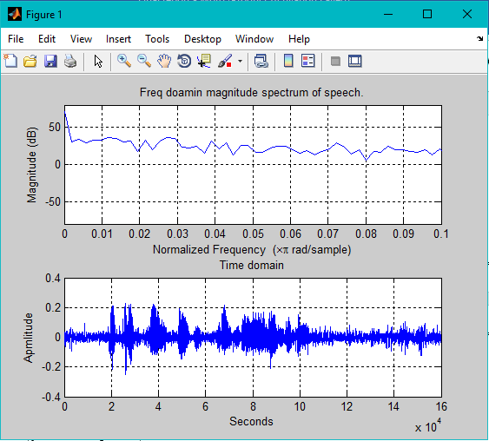

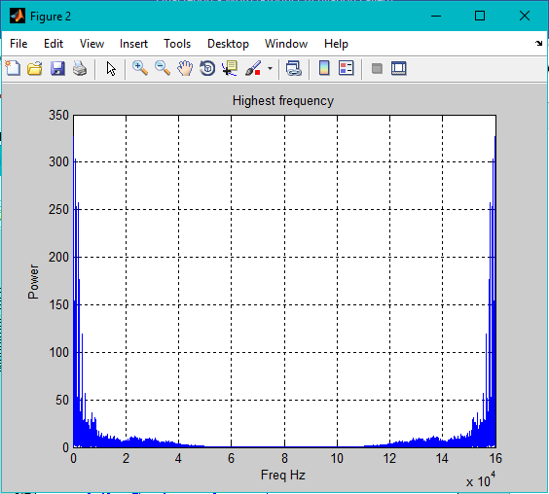

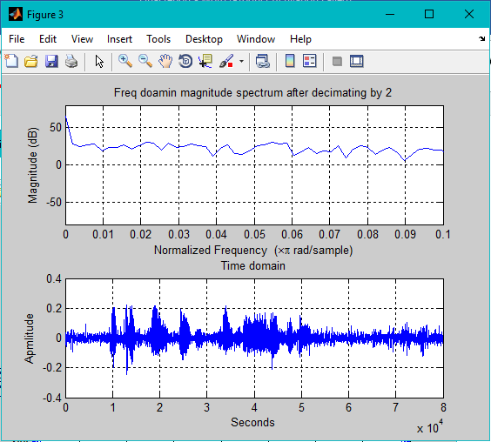

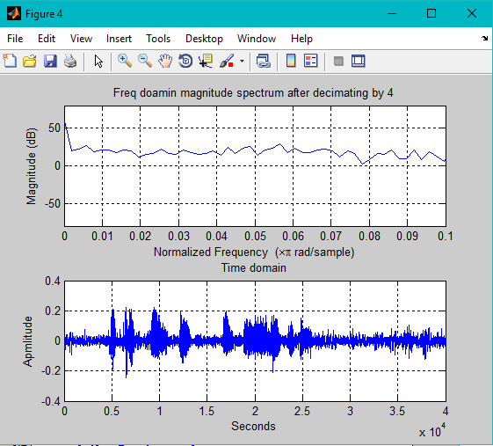

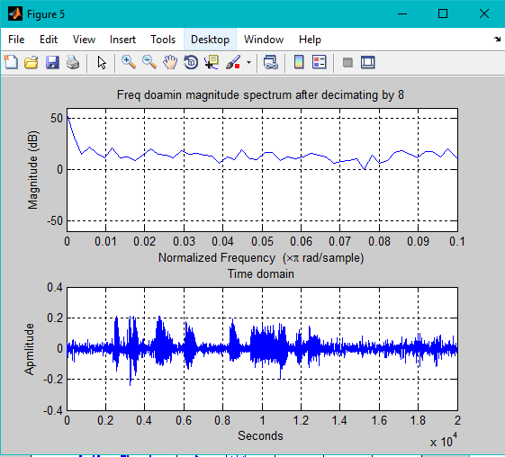

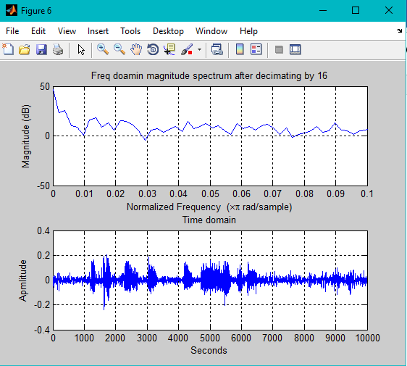

**Results:**

The highest frequency of recorded speech signal is 327kHz.

**Observation on Decimation by Factor 2:**

Data transmitted per unit time is increased so does the speed of transmission or the speed of speech is increased. Another thing we observed by decimating by 2 is that the amplitude of frequency magnitude spectrum is got lowered from amplitude of original frequency magnitude spectrum. For example, if we take any sample point let’s say at 0.1, the amplitude of original frequency magnitude spectrum at that sample point is almost 30dB but when decimated by 2 the amplitude of decimated frequency magnitude spectrum goes to 28dB. Therefore, speech is not that much clear to understand than original speech and time is reduced.

**Observation on Decimation by Factor 4:**

Data transmitted rate is much more increased. By decimating by 4 the amplitude of frequency magnitude spectrum is got much lowered from amplitude of original frequency magnitude spectrum. For example, if we take any sample point let’s say at 0.1, the amplitude of original frequency magnitude spectrum at that sample point is almost 30dB but when decimated by 4 the amplitude of decimated frequency magnitude spectrum goes to 25dB. The decimated speech is very rough and not clear enough to understand because time is more decreased.

**Observation on Decimation by Factor 8:**

Data transmitted per unit time is much more increased and the speed of transmission or the speed of speech is increased. Another thing we observed by decimating by 8 is that the amplitude of frequency magnitude spectrum is got lowered from amplitude of original frequency magnitude spectrum. For example, if we take any sample point lets say at 0.1, the amplitude of original frequency magnitude spectrum at that sample point is almost 30dB but when decimated by 8 the amplitude of decimated frequency magnitude spectrum goes to 18dB. The speech is played so fast that the speech is almost impossible to understand, time is much more reduced.

**Observation on Decimation by Factor 16:**

Data transmitted per unit time is so much increased Another thing we observed by decimating by 16 is that the amplitude of frequency magnitude spectrum is got lowered from amplitude of original frequency magnitude spectrum. For example, if we take any sample point let’s say at 0.1, the amplitude of original frequency magnitude spectrum at that sample point is almost 30dB but when decimated by 16 the amplitude of decimated frequency magnitude spectrum almost goes to 1dB. The rate of speech is so less that the speech is impossible to understand, time is much more reduced.

**Conclusion:**

We recorded the speech signal and plotted its frequency and time domain spectrum. Then decimated the signal by factor of 2 four times. We conclude the result by saying that sampling frequency or the frequency domain expands whereas time domain is compressed when we decimate the speech signal.